Weekly reports are to be emailed to atbecker@uh.edu by 5:00pm on Tuesdays. The purpose of a weekly report is to: (1) give you text and images for your papers, thesis, and dissertation, (2) document progress, (3) identify if you are stuck or need resources.

Weekly report

1. **My *Goals* from last week**

1)Migrate to java and ARGoS to write code for non-overlapping particles.

2) Finish the MATLAB code with non-overlapping where the particles vanish as they reach target space.

**My *Accomplishments* this week**

1. Matlab code now deletes particles as they reach roi. them reach roi.

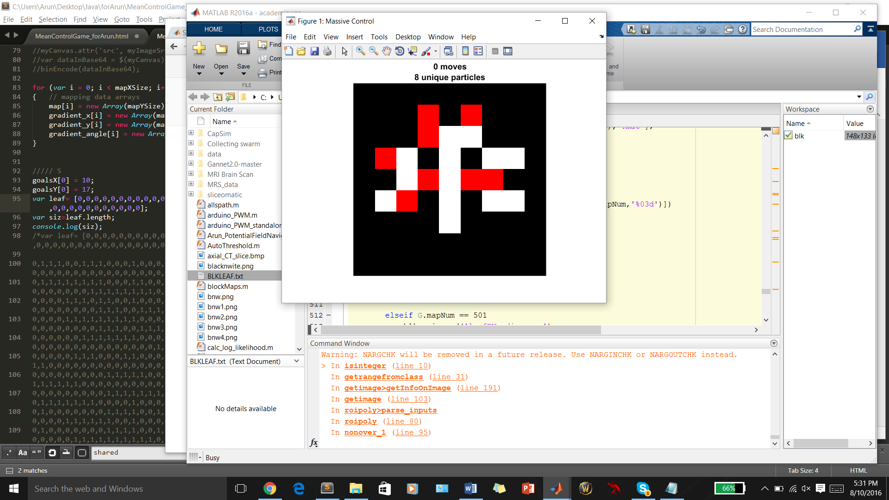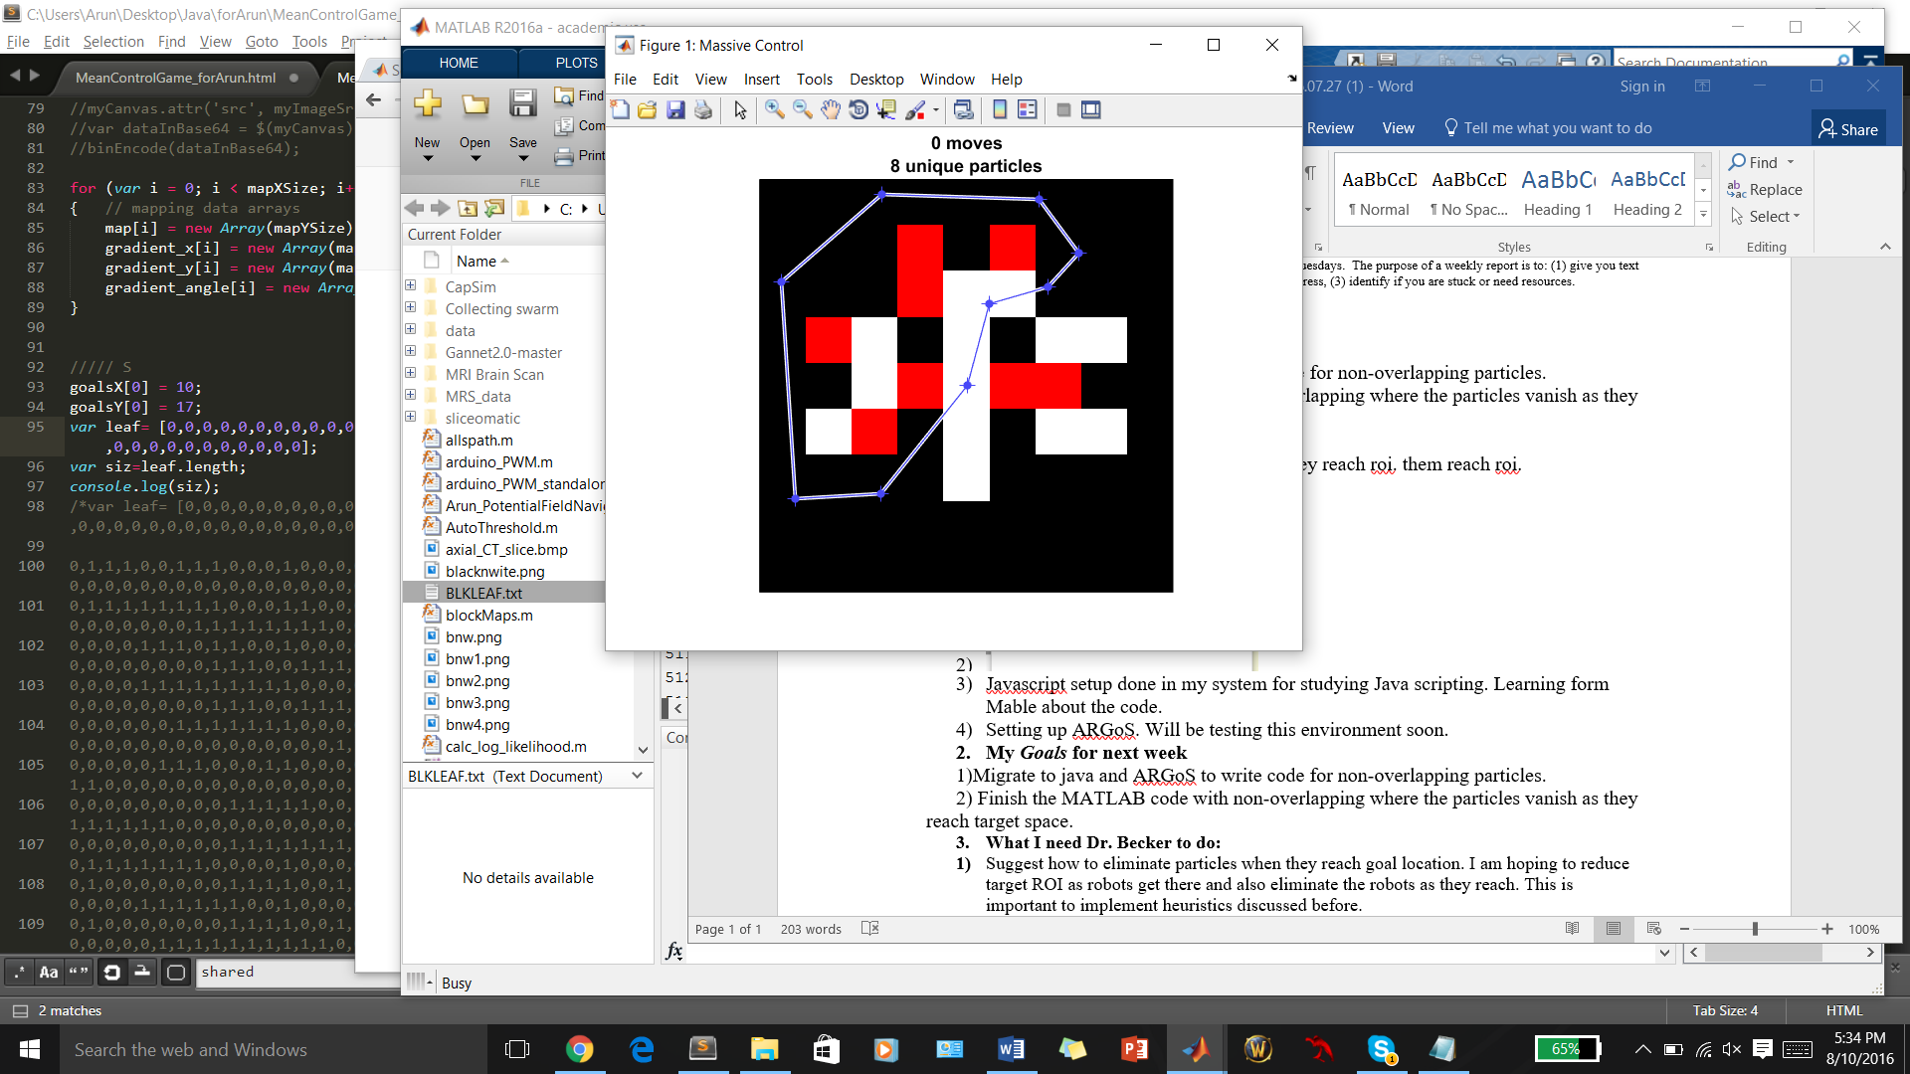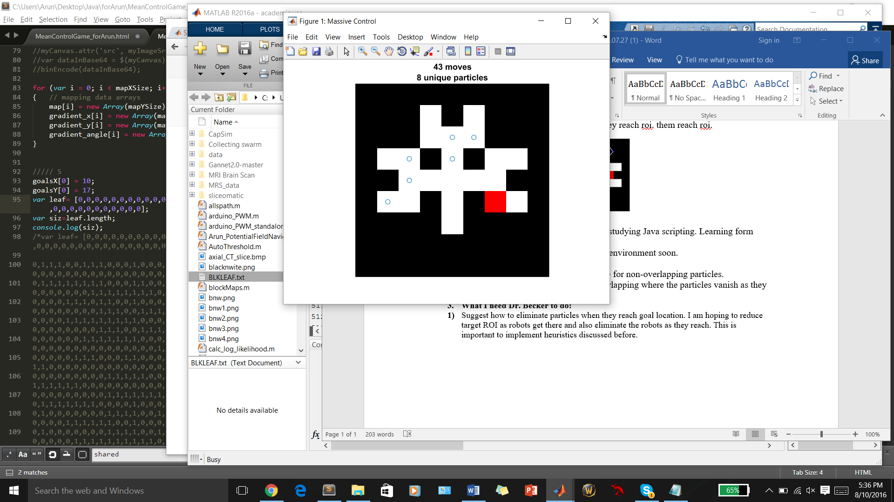

1. Start (b) draw roi (c) region deleted

Note that (c) has one lesser box because of movement.

Works with big map too. Now we just need to change the displayed number of particles.

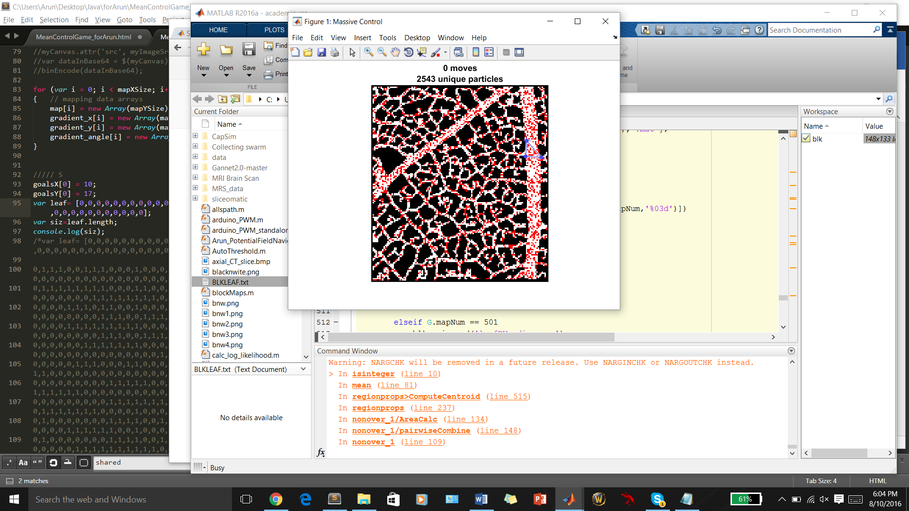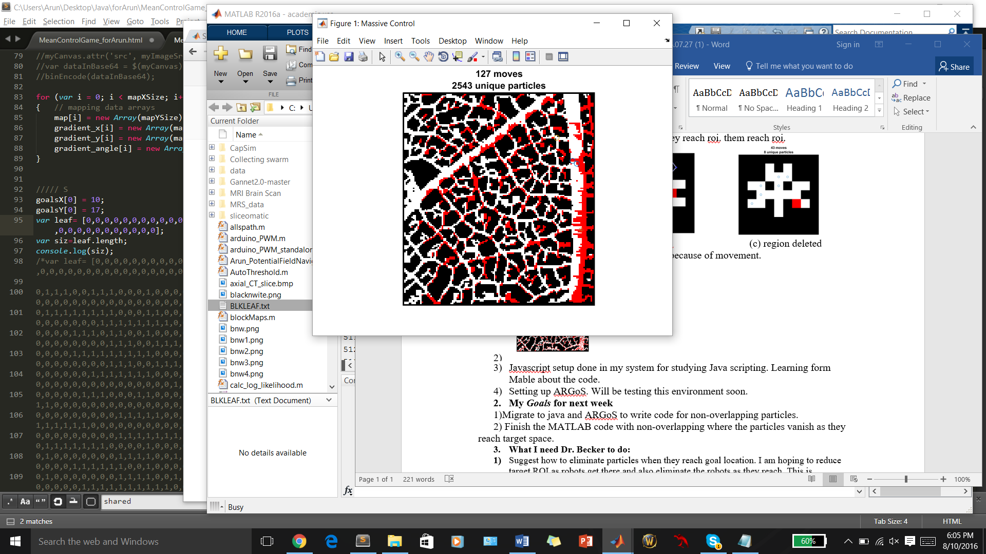

1. Printing going on for 3D parts for Video. 2 new pieces today. Video scheduled for tomorrow.
2. Javascript lessons with Mable. Learnt the variables and how to use console.
3. ARGoS setup too cumbersome. Maybe later.
4. Got opportunity to be in the Authors block of a paper at BCM. Just heard about it.
5. **My *Goals* for next week**

1)Matlab code with large particles shows good speed after fix. No need to migrate if we are still doing basic moves. This will be primary direction.

2) Submit the presentation slides to you by Friday.

3) Submit the schedule for next semester.

4) Prepare abstract for September paper.

1. **What I need Dr. Becker to do:**
2. **Check the name list for the papers and see if name is apt.**